Software Requirements Specification
for
Attendance Monitoring System using facial recognition
Prepared by: Sejal Pathak
Sakina Modi
Aditya Suryawanshi

K.K.Wagh Polytechnic, Nashik
23rd Oct, 2023
Table of Contents
Table of Contents ii
Revision History ii
1. Introduction 1
1.1 Purpose 1
1.2 Document Conventions 1
1.3 Intended Audience and Reading Suggestions 1
1.4 Product Scope 1
1.5 References 1
2. Overall Description 2
2.1 Product Perspective 2
2.2 Product Functions 2
2.3 User Classes and Characteristics 2
2.4 Operating Environment 2
2.5 Design and Implementation Constraints 2
2.6 User Documentation 2
2.7 Assumptions and Dependencies 3
3. External Interface Requirements 3
3.1 User Interfaces 3
3.2 Hardware Interfaces 3
3.3 Software Interfaces 3
3.4 Communications Interfaces 3
4. System Features 4
4.1 System Feature 1 4
4.2 System Feature 2 (and so on) 4
5. Other Nonfunctional Requirements 4
5.1 Performance Requirements 4
5.2 Safety Requirements 5
5.3 Security Requirements 5
5.4 Software Quality Attributes 5
5.5 Business Rules 5
6. Other Requirements 5
Appendix A: Glossary 5
Appendix B: Analysis Models 5
Appendix C: To Be Determined List 6

Revision History
Name | Date | Reason For Changes | Version

Introduction

Purpose
The purpose of this SRS document is to specify the software requirements for the development of an "Attendance System using Face Recognition" product, hereafter referred to as the "System." This document is focused on outlining the software requirements for the entire system, which encompasses both the Android mobile application for teachers and the backend components for face recognition, database management, and attendance tracking.
This SRS defines the scope of the product, including the features and functionality it should offer to meet the objectives of eliminating fake attendance, enhancing the efficiency of attendance management, and improving the security and accuracy of attendance tracking in educational institutes. The scope covers all essential aspects of the System, including real-time face detection and recognition, student data storage, teacher administration, and attendance management.

Document Conventions
This SRS document adheres to the following standards and typographical conventions:
- Priority Levels: Requirements are categorized with priority levels to indicate their relative importance. Priority levels include:
  - High (H): Critical requirements essential for the core functionality and security of the system.
  - Medium (M): Important requirements that contribute significantly to the system's usability and effectiveness.
  - Low (L): Desirable but non-essential features that enhance the user experience.
- Formatting: The document uses consistent formatting for requirement statements. Each requirement statement is preceded by a unique identifier for reference purposes.
- Font Style: Key terms and headings, such as "Introduction", "Overall Description"&"External Interface Requirements" are presented in bold to distinguish them from the main content.
- Acronyms and Abbreviations: Acronyms and abbreviations used within the document are defined the first time they are introduced.

Intended Audience and Reading Suggestions
This SRS document is intended to be a comprehensive reference for a diverse group of :
Developers, Project Managers, Quality Assurance and Testers, System Administrators, Teachers and Educators.
To facilitate effective use of this SRS document, it is recommended that readers follow this sequence:
1) Begin with the "Introduction" (Section 1)
2) Review "Document Conventions" (Section 2) to become familiar with the document's formatting and terminology.
3) Continue with this section, "Intended Audience and Reading Suggestions"
4) Proceed to "Overall Description" (Section 4) for a high-level understanding of the system's context, features, and constraints.

Product Scope
The "Attendance System using Face Recognition" is a cutting-edge software application designed to revolutionize the way student attendance is recorded and managed in educational institutions. The primary purpose of this software is to enhance efficiency, accuracy, and security in the attendance tracking process. By leveraging real-time face detection and recognition technology, this system eliminates the chances of fake attendance, a common issue with traditional methods.

References
[1]. Dipti Kumbhar , Prof. Dr. Y. S. Angal Department of Electronics and Telecommunication, Smart Attendance System using Computer Vision and Machine Learning yogeshangal@yahoo.co.in IRJET 1/4/2022]
[2]. P. Visalakshi, Sushant Ashish Assistant Professor ,Department of Computer Science and Engineering SRM Institute of Science and Technology, Chennai, Tamil Nadu, ATTENDANCE SYSTEM USING MULTI-FACE RECOGNITION , IEEE 27/5/2023]
[3]. CH. VINOD KUMAR , DR. K. RAJA KUMAR PG Scholar, Dept of CS& SE, Andhra University, Vishakhapatnam, AP, India. Assistant Professor, Dept of CS& SE, Andhra University, Vishakhapatnam, AP, India. Face Recognition Based Student Attendance System with OpenCV 15/12/2022]
[4]. Face Recognition based Attendance Management System using Machine Learning. IRJET 06, June 2022 ]

Overall Description

Product Perspective
The "Attendance System using Face Recognition" is a standalone software product designed to address the critical needs of attendance tracking in educational institutions. This system is not a replacement for existing systems but is a novel, self-contained solution. It leverages modern technology to streamline and enhance the process of marking and managing student attendance.
Origin: The idea for this system originated from the need to overcome the limitations and challenges associated with traditional attendance tracking methods, such as roll calls and manual signatures. These methods are time-consuming and prone to inaccuracies due to the potential for proxy attendance.
Context: The system is being developed as an independent, innovative solution to improve the efficiency and accuracy of attendance management. It is not part of an existing product family or an extension of any prior system. Its development stems from a recognition of the value of biometric technology, particularly facial recognition, in the educational sector.

Product Functions
- Real-Time Face Detection: The system should capture video frames and detect faces in real-time using a connected camera or image-capturing device.
- Facial Recognition: For each detected face, the system must perform facial recognition by comparing facial measurements with a database of known students.
- Attendance Marking: Teachers should be able to mark attendance for recognized students with a single action, such as tapping on the student's face on the interface.
- Student Data Management: The system must allow administrators to manage student data, including attendance records, performance in practicals, and student ratings.
- Data Retrieval: Teachers can scan a student's face to retrieve their data, including attendance, performance, and rating.

User Classes and Characteristics
- Teachers (Administrators):
- High-frequency users, as they are responsible for daily attendance marking.
- Technical proficiency varies, from basic to moderate.
- Have administrative privileges, allowing access to all system features.
- May need to manage student data, including attendance, performance, and ratings.

- System Administrators:
- Low frequency users, as they manage system settings and configurations.
- High technical proficiency, with expertise in system administration.

- Database Managers:
- Low to moderate frequency users, involved in database maintenance and backups.
- High technical proficiency, particularly in database management.

Operating Environment
- Hardware Platform:
Mobile Devices: The primary user interface for teachers and students is an Android-based mobile application. Therefore, the software is compatible with Android devices such as smartphones and tablets.
- Operating System:
Android OS: The Android application will be developed to run on Android OS. It will be compatible with a range of Android OS versions, but specific versions will be determined during the development process to maximize the user base.
- Software Components:
Face Recognition Software: The system will include face recognition software, which may involve libraries or frameworks for real-time face detection and recognition. Compatibility with these software components must be ensured.

Design and Implementation Constraints
- Hardware Limitations:
Mobile Device Capabilities: The software must work within the constraints of the hardware capabilities of Android-based mobile devices. This includes considerations for processing power, memory, and camera quality.
- Data Privacy: The system must adhere to data privacy regulations and standards to ensure the security and confidentiality of student information, especially when using biometric data (facial recognition).
- Selection of Recognition Algorithm: The system's design should accommodate the chosen face recognition algorithm, which may be based on existing libraries or frameworks.
- Authentication and Authorization: Security measures for user authentication and authorization must be implemented to prevent unauthorized access and data breaches.
- User Experience (UX): The software's user interface (UI/UX) should be designed with a focus on usability and user-friendliness to accommodate users with varying technical proficiency.

User Documentation
- User Manual:
A comprehensive user manual will be created to guide teachers, students, system administrators, and other users through the features and functionalities of the software.
- Online Help and Tutorials:
Online help and interactive tutorials will be available within the software interface.
- Frequently Asked Questions (FAQs):
A FAQ section will be included in the user documentation to address common queries and concerns that users may have while using the software.
- Troubleshooting Guide:
A troubleshooting guide will be provided to help users diagnose and resolve common issues they might encounter when using the system.
- Release Notes:
Release notes will be available to inform users about updates, new features, bug fixes, and any changes in the software with each new release or version.

Assumptions and Dependencies
Assumptions:

- Camera Availability: It is assumed that the Android-based mobile devices used by teachers and students will have functional built-in cameras or be equipped with external camera accessories. The software relies on camera availability for face detection and recognition.

- Student Consent: It is assumed that students using the system have given their consent for the collection and use of their facial data for attendance tracking. Compliance with data privacy regulations and obtaining necessary consents is assumed.

- Stable Internet Connection: The software relies on an internet connection for certain functions, such as accessing the database for data retrieval. It is assumed that users will have access to a stable internet connection.

- Availability of a Database Management System: The software assumes that a database management system (e.g., MySQL, MongoDB) will be available and properly configured to store and manage student data. The choice of the database system is an assumption.

Dependencies:

- Third-Party Face Recognition Library: The project depends on the successful integration of a third-party or in-house developed face recognition library or framework for accurate facial recognition. Any delays or issues with this dependency may impact the project timeline.

- Hardware and Android Compatibility: The project depends on the compatibility of the software with a range of Android-based mobile devices, as well as the availability of functional cameras and stable internet connections on these devices.

- Database Management System: The project is dependent on the choice of a specific database management system for storing student data. The selection of the database system and its proper configuration is critical.

External Interface Requirements

User Interfaces
- User Interface Design: The teacher interface will be designed with an intuitive and user-friendly layout to facilitate easy navigation.
- Main Features: The interface will provide options for real-time face detection, marking attendance, and managing student data.
- Authentication: Teachers will need to log in with a username and password to access the interface.
- Attendance Marking: Teachers can initiate attendance marking by scanning the faces of students. A simple tap on a student's face should suffice.
- Data Management: Teachers will be able to manage student data, including attendance records, performance in practicals, and student ratings, through the interface.
- Error Messages: The interface should display error messages and alerts in a consistent format to provide users with clear feedback in case of issues.

Hardware Interfaces
- Camera:
Nature of Interaction: The software will interact with the camera or image-capturing device to capture video frames and perform real-time face detection.
Supported Devices: The software should be compatible with a range of Android-based mobile devices equipped with cameras.
Data Interaction: The camera or image-capturing device will provide video frames as input data to the software for face detection and recognition.
Communication Protocol: The software should use standard communication protocols to access the camera, such as Android's camera API.

Software Interfaces
- Database Management System (DBMS):
Name and Version: The specific DBMS used (e.g., MySQL, MongoDB) and its version will be determined during the development phase.
Data Interaction: The software will communicate with the DBMS to store and retrieve student data, including images, attendance records, and performance data.
Purpose: The DBMS serves as the primary data repository for the system, ensuring data integrity and accessibility.

- Face Recognition Software:
Name and Version: The specific face recognition library or framework used for real-time face detection and recognition will be identified during development.
Data Interaction: The software will interact with the face recognition software to process video frames and recognize faces.
Purpose: The face recognition software is critical for the core functionality of the system, enabling accurate attendance tracking.

- Android Operating System:
Name and Version: The software is designed to run on Android OS, and compatibility with different Android versions will be ensured during development.
Data Interaction: The software will run on the Android OS and use its APIs for camera access and device communication.
Purpose: The Android OS provides the underlying framework for the software to run on Android-based mobile devices.

Communications Interfaces
- Internet Communication:
Protocols: The software will use standard internet communication protocols, such as HTTP or HTTPS, for secure data transmission.
Purpose: Internet communication is necessary for data exchange with external servers or online resources, such as cloud-based databases or web services.
- Local Network Communication:
Protocols: The software may use local network protocols (e.g., Wi-Fi) to establish connections between devices within the same network.
Purpose: Local network communication may be needed for syncing data between devices or for system administration and configuration. For example, an administrator may need to configure system settings from a different device on the same local network.
- Synchronization Mechanisms:
Data Sync: The software may require synchronization mechanisms to ensure data consistency between the mobile application and the database.
Purpose: Data synchronization is crucial to keep student data up to date and consistent across devices. This ensures that the same data is accessible and accurate on both the teacher's device and the student's device.
- Data Transfer Rates:
Data Transfer Speed: The software should aim for efficient data transfer rates to provide a smooth user experience.
Purpose: Faster data transfer rates are necessary for real-time face detection and recognition. Slower data transfer can lead to delays in attendance marking.

System Features

4.1 User Authentication:

4.1.1 Description and Priority
Feature Description: This feature allows teachers (administrators) and students to log into the system securely.
Priority: High

4.1.2 Stimulus/Response Sequences
Stimulus/Response: Teacher Login
Stimulus: A teacher initiates the login process by providing a username and password.
Response: The system validates the credentials. If valid, the teacher gains access to administrative functions.

4.2 Real-Time Face Detection:

4.2.1 Description and Priority
Feature Description: The system should be able to capture video frames and detect faces in real-time using the device's camera.
Priority: High

4.2.2 Stimulus/Response Sequences
Stimulus/Response 1: Real-Time Face Detection
Stimulus: The system accesses the device's camera.
Response: The camera captures video frames, and the system processes the frames to detect faces.

4.2.3 Functional Requirements
REQ-1: Camera Access
The system should access the device's camera.
REQ-2: Real-Time Face Detection
The software should capture and process video frames in real-time.
REQ-3: Face Detection Algorithm
The system should use a face detection algorithm for real-time detection.

Other Nonfunctional Requirements

Performance Requirements
5.1.1 Real-Time Face Detection:
Requirement: The system must achieve real-time face detection with a minimum frame processing rate of 30 frames per second (FPS).
Rationale: Real-time face detection is critical for marking attendance without causing delays or interruptions during class sessions. A minimum frame processing rate of 30 FPS ensures smooth and timely face detection.
5.1.2 Face Recognition Accuracy:
Requirement: The system must achieve a minimum accuracy rate of 98% in face recognition.
Rationale: High accuracy in face recognition is necessary to minimize false positives or negatives when marking attendance. A minimum accuracy rate of 98% ensures reliable identification.
5.1.3 Data Retrieval Latency:
Requirement: Data retrieval for students, including attendance records and performance information, must occur within a maximum of 2 seconds.
Rationale: Quick data retrieval is crucial for teachers and students accessing their information. A maximum latency of 2 seconds ensures a responsive user experience.
5.1.4 Scalability:
Requirement: The system should be able to handle attendance marking for up to 100 students simultaneously.
Rationale: Scalability is important to accommodate larger classes. Supporting up to 100 students at once ensures the system's adaptability to various class sizes.

Safety Requirements
5.2.1 Privacy Protection:
Requirement: The system must adhere to data privacy regulations and standards, such as GDPR or HIPAA, to protect the privacy of student data.
Safeguards: Implement data encryption during transmission and storage. Ensure that only authorized users can access sensitive student data.
Rationale: Protecting the privacy of student data is essential to comply with legal regulations and to prevent unauthorized access to personal information.
5.2.2 Facial Recognition Safeguards:
Requirement: The system must ensure that facial recognition is used only for attendance tracking and must not store or use facial data for any other purposes.
Safeguards: Implement data anonymization techniques to store facial data securely. Ensure that facial data is not used for any other applications.
Rationale: Preventing the misuse of facial data is essential to protect the privacy and security of individuals.

Security Requirements
5.3.1 User Authentication
Requirement: The system must implement strong user authentication mechanisms for both teachers (administrators) and students.
Authentication Methods: Use secure authentication methods, such as username and password, or implement two-factor authentication (2FA).
Rationale: Strong user authentication is necessary to prevent unauthorized access to the system and to protect student data.

5.3.2 Data Encryption
Requirement: Data transmission and storage should be encrypted using industry-standard encryption protocols (e.g., SSL/TLS).
Encryption Standards: Follow encryption standards to secure data during transmission and storage.
Rationale: Data encryption ensures that sensitive information, including student data, remains confidential and protected from unauthorized access.

5.3.3 Access Control
Requirement: Implement role-based access control to restrict system access based on user roles (e.g., teacher, student, administrator).
Access Control Policies: Define and enforce access control policies to limit access to specific functionalities.
Rationale: Role-based access control helps prevent unauthorized access and ensures that users can only perform actions relevant to their roles.

5.3.4 Data Privacy Compliance
Requirement: The system must adhere to relevant data privacy regulations, such as GDPR or HIPAA, to protect user privacy.
Privacy Measures: Implement data anonymization, pseudonymization, or other privacy-enhancing measures as required.
Rationale: Compliance with data privacy regulations is crucial to protect user privacy and avoid legal issues.

Software Quality Attributes
5.4.1 Usability
Attribute: The system should be user-friendly and easy to use.
Preference: Ease of use is a higher priority than ease of learning.
Rationale: Users should find it straightforward to navigate and interact with the system, which is especially important for teachers and students who may not have extensive technical backgrounds.

5.4.2 Reliability
Attribute: The system should be highly reliable.
Quantitative Target: The system should have a minimum uptime of 99.9%.
Rationale: Reliability is crucial to ensure that the system is available when needed, especially for taking attendance during classes.

5.4.3 Maintainability
Attribute: The system should be easily maintainable and upgradable.
Quantitative Target: The system should allow for updates and maintenance with minimal downtime (e.g., updates can be applied during non-peak hours).
Rationale: Ease of maintenance is essential for keeping the system up to date and secure.

Business Rules
5.5.1 User Roles
Rule: Teachers are designated as administrators with full access to manage student data and mark attendance.
Implication: Functional requirements must include user authentication and authorization mechanisms to differentiate between teachers (administrators) and students.

5.5.2 Data Privacy Compliance
Rule: The system must comply with data privacy regulations and standards, such as GDPR or HIPAA, to protect student data.
Implication: Functional requirements must include data anonymization, encryption, and other privacy measures to ensure compliance with data privacy rules.

5.5.6 Data Accuracy and Corrections
Rule: Teachers (administrators) should have the ability to make corrections to student attendance and performance data.
Implication: Functional requirements should include data correction and editing features for administrators.

Other Requirements
6.1 Database Requirements
Requirement: The system must maintain a secure and well-structured database to store student information, attendance records, and performance data.
Rationale: A reliable and organized database is essential for efficient data management and retrieval.

6.2 Internationalization and Localization
Requirement: The system should be designed to support multiple languages and regions to accommodate international users.
Rationale: Internationalization and localization are important to ensure the system can be used in diverse educational settings worldwide.

6.3 Legal Compliance
Requirement: The system must comply with all relevant local, national, and international laws and regulations related to education, data privacy, and software use.
Rationale: Legal compliance is essential to avoid legal issues and ensure responsible operation.

6.4 Backup and Recovery
Requirement: The system should implement regular automated backups of the database and have a disaster recovery plan in place.
Rationale: Data loss prevention and system recovery capabilities are critical for ensuring continuity in case of unexpected issues.

6.5 Reporting and Analytics
Requirement: The system should provide reporting and analytics features for teachers to analyze attendance and student performance data.
Rationale: Reporting and analytics features assist teachers in making informed decisions and improving educational processes.

6.6 Third-Party Integrations
Requirement: The system should have the capability to integrate with third-party educational tools or services, as needed.
Rationale: Integration with other educational tools or services can enhance the system's functionality and adaptability.

Appendix A: Glossary

SRS: Software Requirements Specification.

GUI: Graphical User Interface.

FPS: Frames Per Second.

GDPR: General Data Protection Regulation.

HIPAA: Health Insurance Portability and Accountability Act.

2FA: Two-Factor Authentication.

SSL: Secure Sockets Layer.

TLS: Transport Layer Security.

Appendix B: Analysis Models
- Data Flow Diagram:
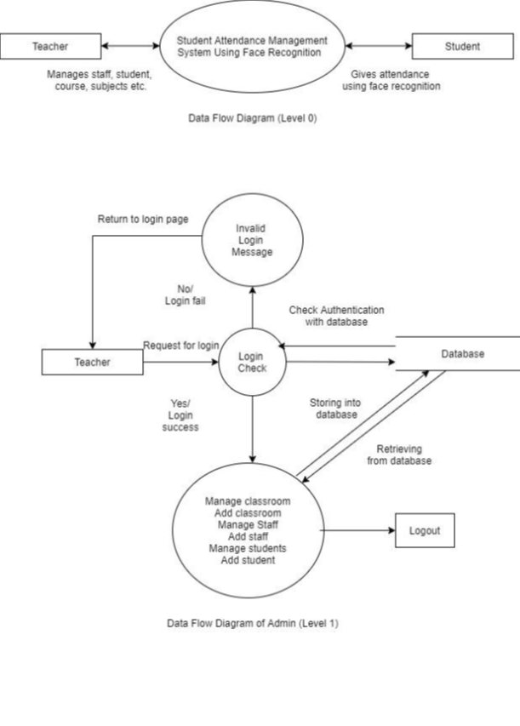
2)Use Case Diagram
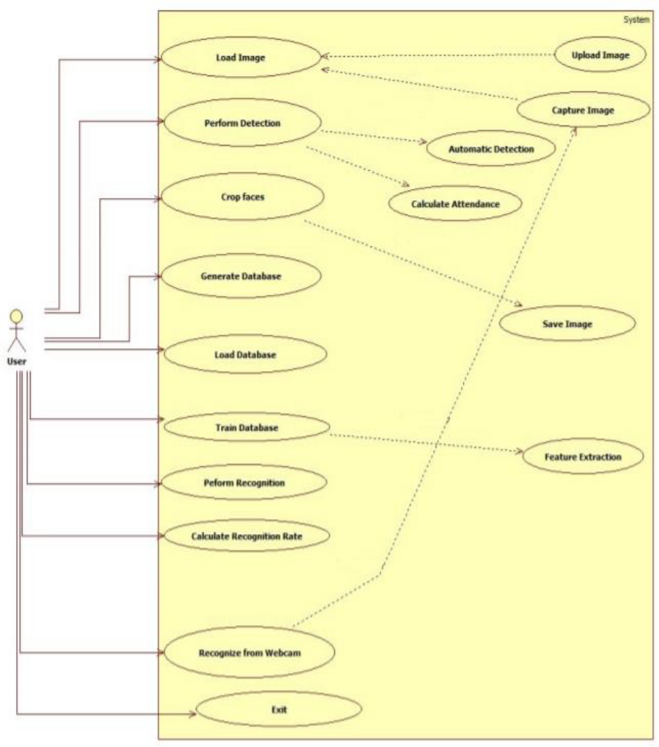

Appendix C: To Be Determined List
TBD - [Purpose]
TBD - [Document Conventions]
TBD - [Intended Audience and Reading Suggestions]
TBD - [Product Scope]
TBD - [Product Perspective]
TBD - [Product Functions]
TBD - [User Classes and Characteristics]
TBD - [Operating Environment]
TBD - [Design and Implementation Constraints]
TBD - [User Documentation]
TBD - [Assumptions and Dependencies]
TBD - [User Interfaces]
TBD - [Hardware Interfaces]
TBD - [Software Interfaces]
TBD - [Communications Interfaces]
TBD - [System Features]

